**23CSE111**

**OBJECT-ORIENTED**

**PROGRAMMING**

**LAB MANUAL**



**Department of computer science and engineering**

**Amrita School of Engineering**

**Amrita Vishwa Vidyapeetham, Amaravati Campus**

# **Name:** E . Aamuktha

**Verified By: Roll No:** 24047

**Date of Submission: Class:** CSE-A

**Semester:** 2

|  |  |  |  |  |
| --- | --- | --- | --- | --- |
| S.No. | Title | Date | Page No. | Signature |
| Week 1 |  | 27-01-2025 |  |  |
| 1. | How to download and install Java Software. |  | 3 |  |
| 2. | Write a Java Program to print the message “Welcome to Java Programming”. |  | 6 |  |
| 3. | Write a Java program that prints: Name, Roll.no. , section of a student. |  | 7 |  |
| Week 2 |  | 10-02-2025 |  |  |
| 1. | Write a java program to calculate the area of a rectangle. |  | 8 |  |
| 2. | Write a java program to temperature from Celsius to Fahrenheit and vica-versa. |  | 9 |  |
| 3. | Write a java program to calculate the simple interest. |  | 10 |  |
| 4. | Write a java program to find the largest of three numbers, using ternary operator. |  | 11 |  |
| 5. | Write a java program to find the factorial of a number. |  | 12 |  |
| Week 3 |  | 24-02-2025 |  |  |
|  | To create a java program with the following instructions:   1. Create a class with name “Car” 2. Create 4 attributes, named: car_color, car_brand, fuel_type, mileage 3. Create 3 methods, named: start(), service(), stop() 4. Create 3 objects, named: car1, car2, car3 5. Create a constructor, which should print, “Welcome to car garage”. |  | 13 |  |
|  | To write a java program to create a class named BankAccount, with 2 methods deposit() and withdraw().   1. deposit(): Whenever an amount is deposited, it has to be update the current amount. 2. withdraw(): Whenever an amount is withdrawn, it has to be less than the current amount , else print (“Insufficient funds”) |  | 15 |  |
|  |  |  |  |  |

**WEEK 1**

**Program 1**

**Aim:** How to download and install Java software

**Procedure:**

**Step 1: To download Java software**

1. Open your web browser, and search for Java Oracle download in the search bar.
2. Open Java Downloads | Oracle India.
3. Scroll down and click on JDK 21(Java SE Development Kit 21.0.6 downloads)
4. Select your operating system.(Windows)
5. Download X64 Installer.

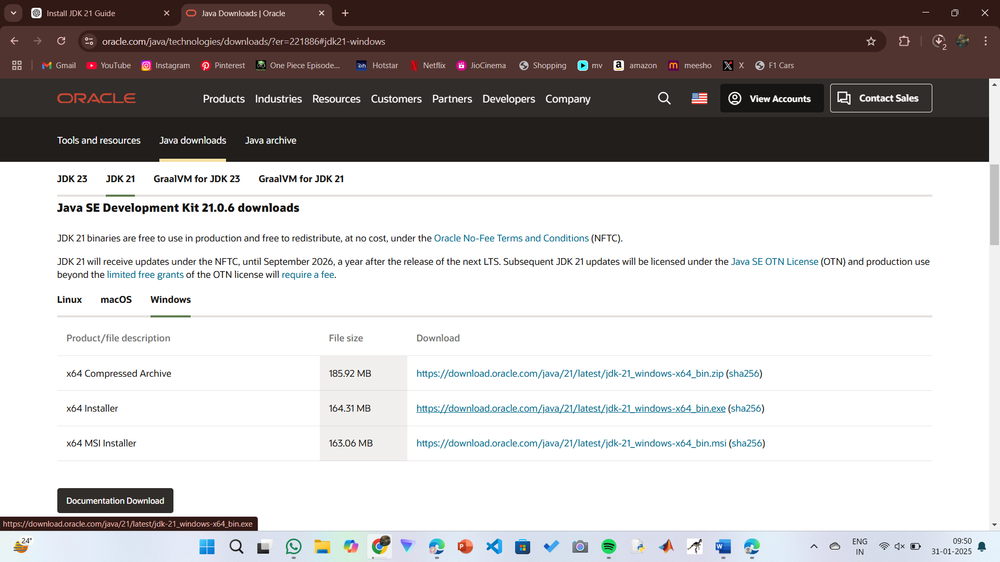

**Step 2: To install Java on your system**

1. For installation, locate the downloaded jdk-21_windows-x64_bin.exe file.
2. Double-click to launch the installer.
3. Click next on setup wizard.
4. Choose the installation path. (C:\Program Files\Java\jdk-21)
5. Click next, then click install.
6. Wait for installation to complete.
7. Click on close, once the installation is complete.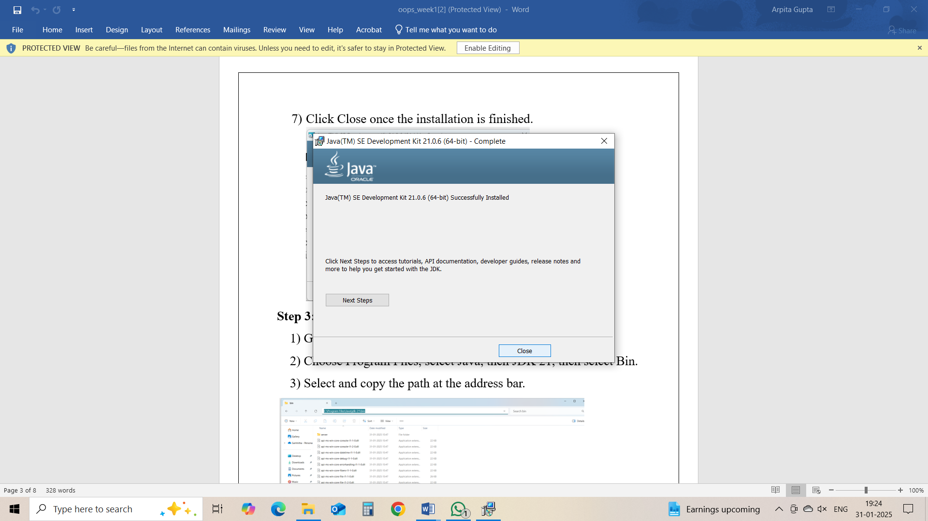

**Step 3: Setup a path**

1. Go to C drive on desktop.
2. Choose Program Files > Java > jdk21 > bin
3. Select and copy the path at the address bar.

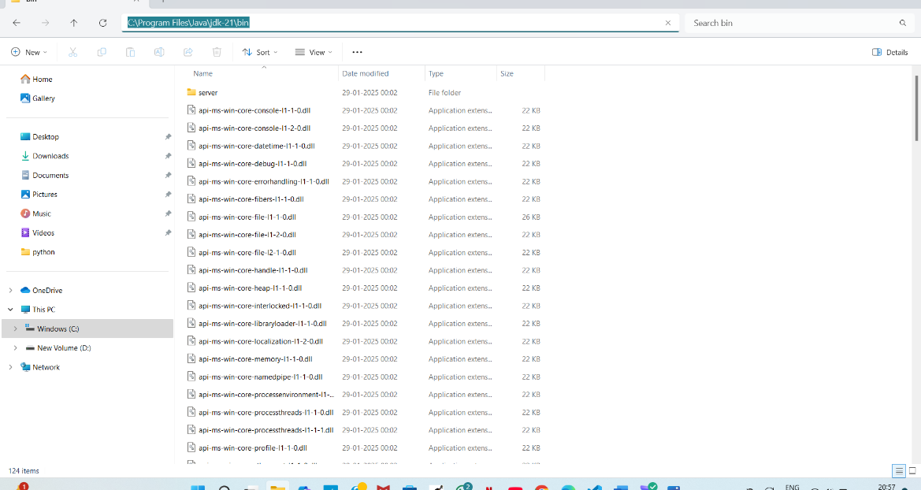

**Step 4: Open System Properties**

1. Press Windows + R, type sysdm.cpl, and click Ok.
2. The System Properties window will open.
3. Navigate to the Advanced tab.
4. Click on Environment Variables at the bottom.

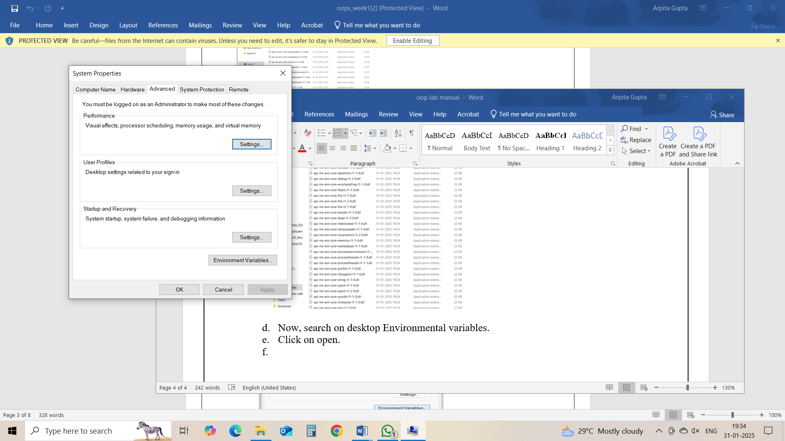

**Step 5: Set JAVA_HOME**

1. Under System Variables, click New.
2. Set the Variable name as JAVA_HOME.
3. Set Variable value as C:\Program Files\Java\jdk-21 (or your installation path).
4. Click OK.

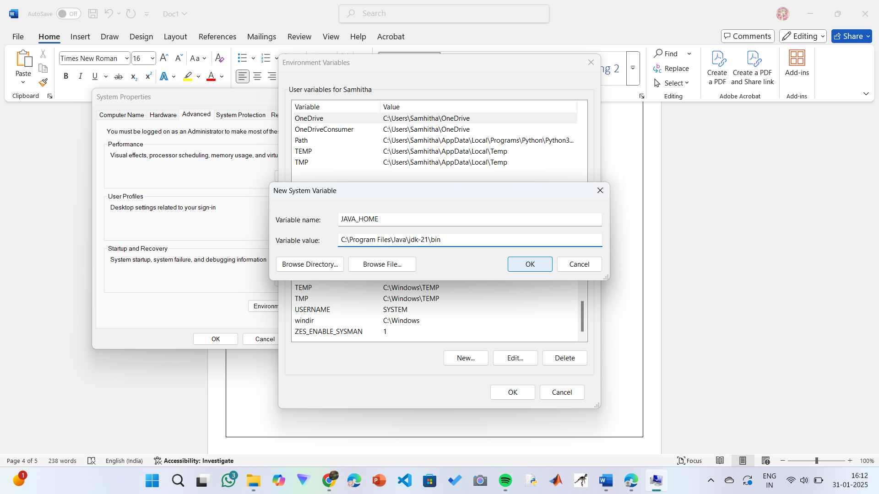

**Step 6: Update PATH Variable**

1. In System Variables, find Path and click Edit.
2. Click New and add: C:\Program Files\Java\jdk-21\bin
3. Click OK to save.

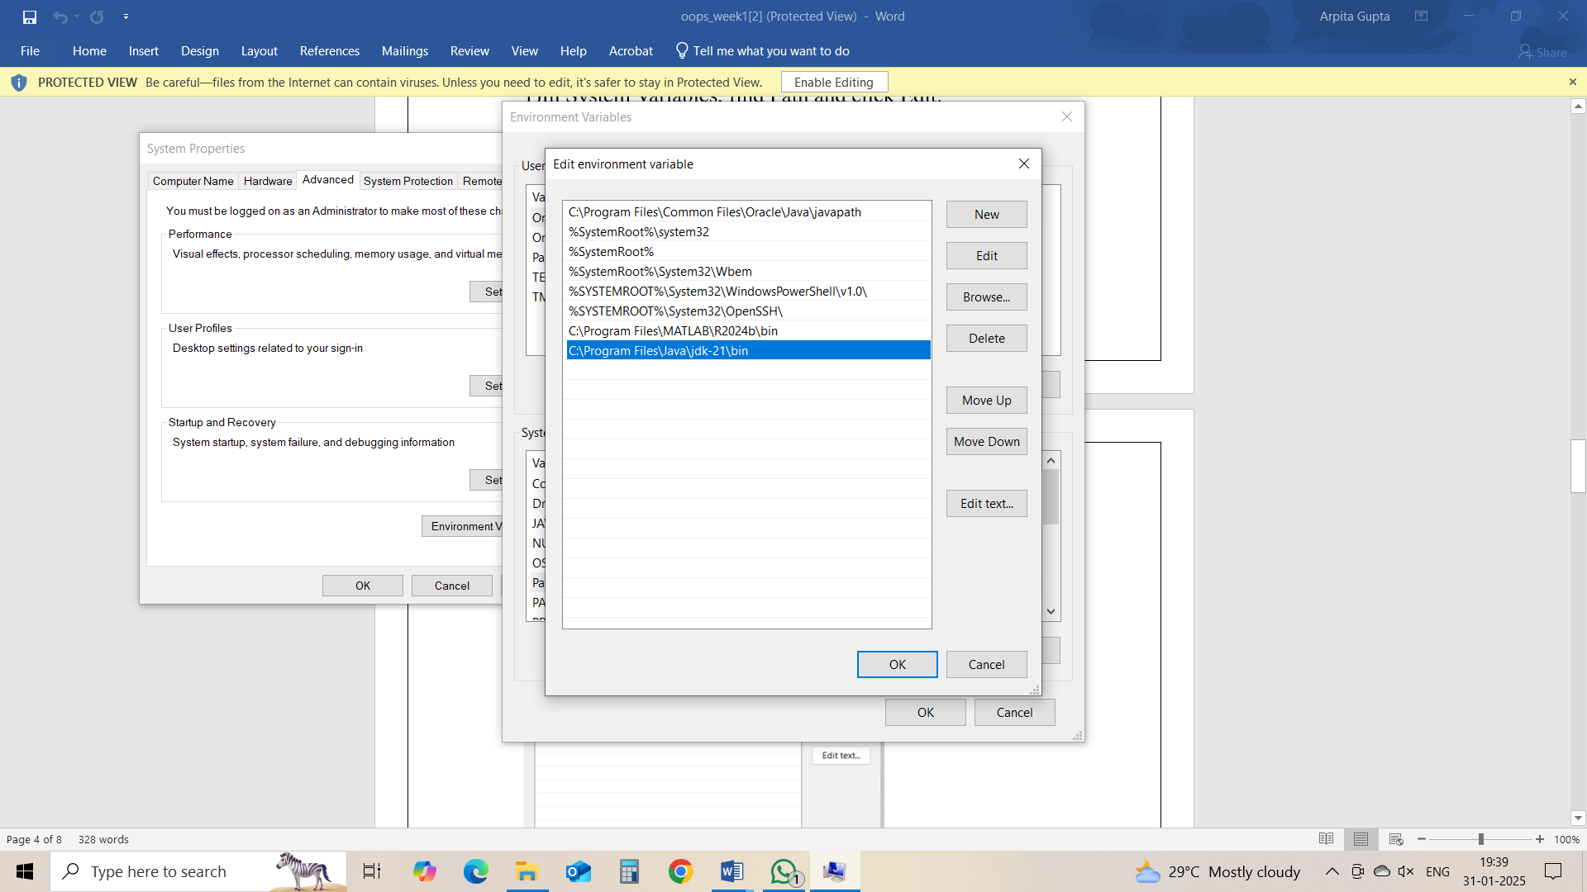

**Step 7:Verify Installation**

1. Open Command Prompt.
2. Type the following command: **java --version** and press Enter.

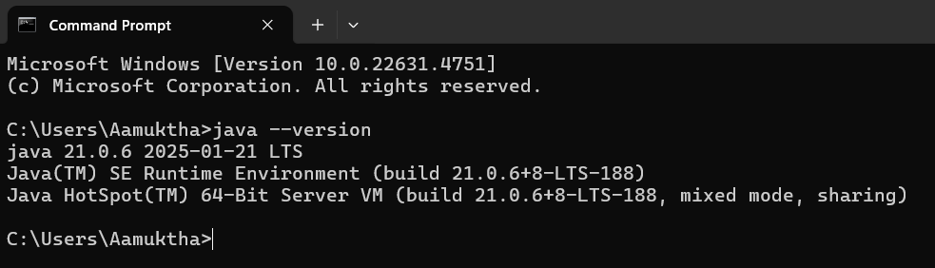

1. To check the java compiler type: **javac –version.**

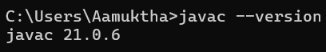

**Program 2:**

**Aim:** Write a Java Program to print the message “Welcome to Java Programming”

**Code:**

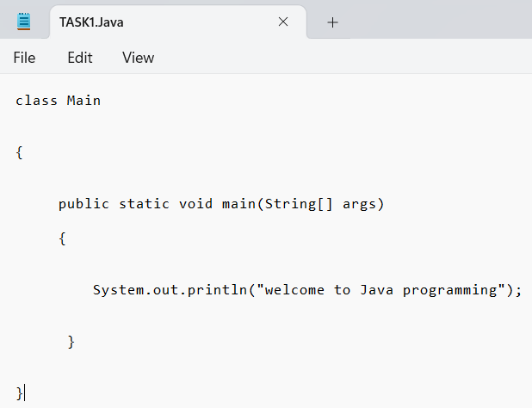

**Output:**

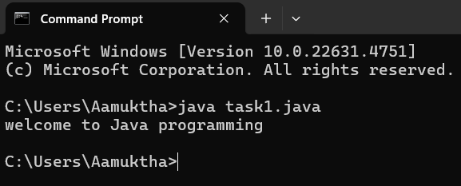

**Error:**

|  |  |  |
| --- | --- | --- |
| **Sno.** | **Error message** | **Error rectification** |
| 1. | error: ';' expected  System.out.println("Welcome to Java Programming") | Adding a semi-colon at the last  System.out.println("Welcome to Java Programming"); |
| 2. | error: reached end of file while parsing  } | Placing a curly bracket at the end of file, to close the class |

**Concepts to be known:**

1. System.out.println(“ “); - It is used to print string inside the quotes. After printing, the cursor moves to the beginning of the next line.

**Program 3:**

**Aim:** Write a Java Program to print the Name, Roll.no. and Section of a student.

**Code:**

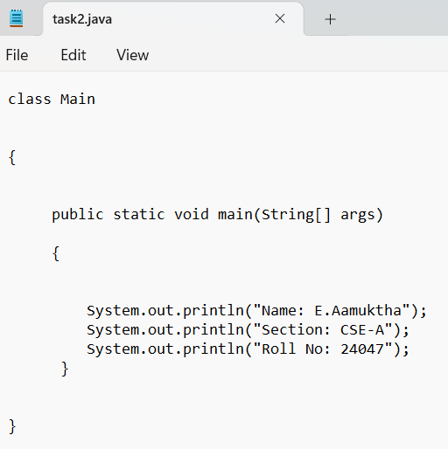

**Output:**

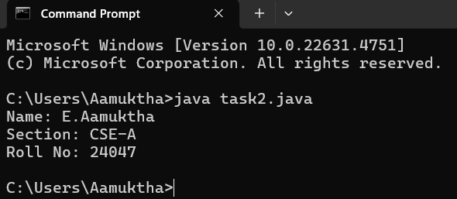

**Error:**

|  |  |  |
| --- | --- | --- |
| **Sno.** | **Error message** | **Error rectification** |
| 1. | error: incompatible types: int cannot be converted to String  String sc=input.nextInt(); | String sc=input.next() |
| 2. | error: incompatible types: String cannot be converted to char  char sc=input.next(); | Change the data type to String |

**Concepts to be known:**

1. import java.util.Scanner; - To accept input from user, Scanner class under util package has to be imported.
2. Scanner input=new Scanner(System.in); - Used to create a Scanner object
3. String nm=input.next(); - Used to read the String data type stored under the object created
4. int rn=input.nextInt(); - Used to read the integer data type stored under the object created
5. System.out.println(“ “); - It is used to print string inside the quotes. After printing, the cursor moves to the beginning of the next line.

**WEEK 2**

**Program 1**

**Aim:** Write a java program to calculate the area of a rectangle.

**Code:**

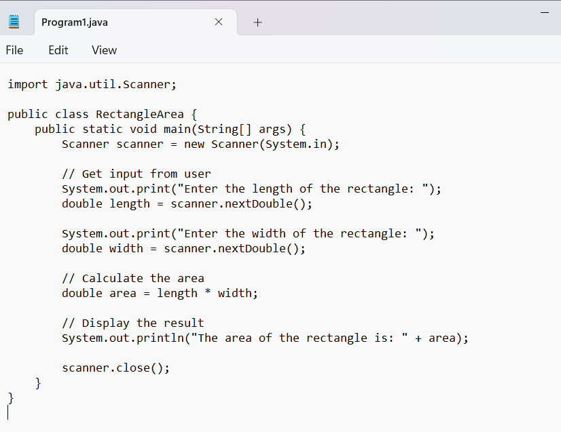

**Output:**

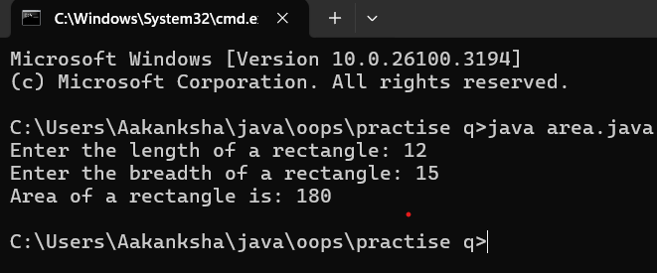

**Error:**

|  |  |  |
| --- | --- | --- |
| **Sno.** | **Error message** | **Error rectification** |
| 1. | error: incompatible types: Scanner cannot be converted to System  System input= new Scanner(System.in); | Change System into Scanner |

**Concepts to be known:**

1. import java.util.Scanner; - To accept input from user, Scanner class under util package has to be imported.
2. Scanner input=new Scanner(System.in); - Used to create a Scanner object
3. int ln=input.nextInt(); - Used to read the integer data type stored under the object created
4. System.out.println(“ “); - It is used to print string inside the quotes. After printing, the cursor moves to the beginning of the next line.

**Program 2**

**Aim:** Write a java program to convert temperature from Celsius to Fahrenheit and vica-versa.

**Code:**

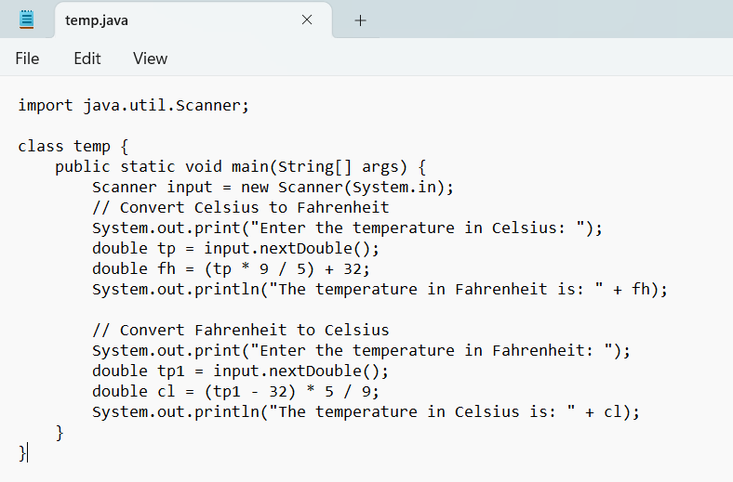

**Output:**

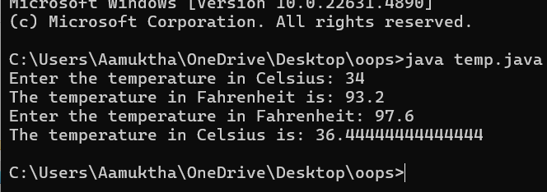

**Error:**

|  |  |  |
| --- | --- | --- |
| **Sno.** | **Error message** | **Error rectification** |
| 1. | error: cannot find symbol  fh=(tp*9/5)+32; | Declare the variable:  double fh=(tp*9/5)+32; |
| 2. | error: ';' expected  System.out.print("Enter the temp in Farenheit:") | Add a semicolon at the end of the statement  System.out.print("Enter the temp in Farenheit:"); |

**Concepts to be known:**

1. import java.util.Scanner; - To accept input from user, Scanner class under util package has to be imported.
2. Scanner input=new Scanner(System.in); - Used to create a Scanner object
3. double fh=input.nextDouble(); - Used to read double data type stored under the object created
4. System.out.println(“ “); - It is used to print string inside the quotes. After printing, the cursor moves to the beginning of the next line.

**Program 3:**

**Aim:** Write a java program to calculate the simple interest.

**Code:**

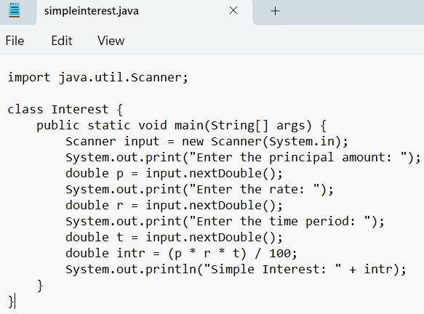

**Output:**

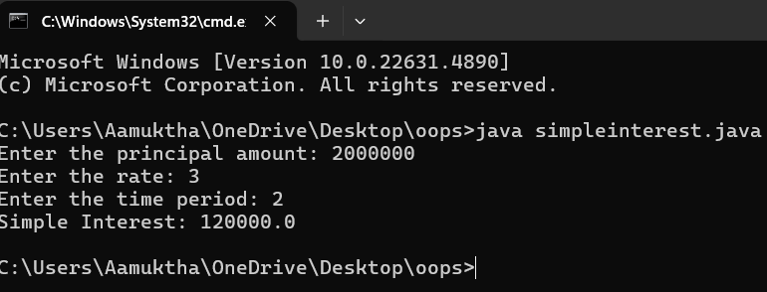

**Error:**

|  |  |  |
| --- | --- | --- |
| **Sno.** | **Error message** | **Error rectification** |
| 1. | error: ';' expected  double intr=(p*r*t)/100 | Add a semicolon at the end of the statement  double intr=(p*r*t)/100; |
| 2. | error: cannot find symbol  double intr=(p*r*t)/100;  symbol: variable p  location: class interest | Create a reader object  double p=input.nextDouble(); |

**Concepts to be known:**

1. import java.util.Scanner; - To accept input from user, Scanner class under util package has to be imported.
2. Scanner input=new Scanner(System.in); - Used to create a Scanner object
3. double p=input.nextDouble(); - Used to read double data type stored under the object created
4. System.out.println(“ “); - It is used to print string inside the quotes. After printing, the cursor moves to the beginning of the next line.

**Program 4**

**Aim:** Write a java program to find the largest of three numbers, using ternary operator.

**Code:**

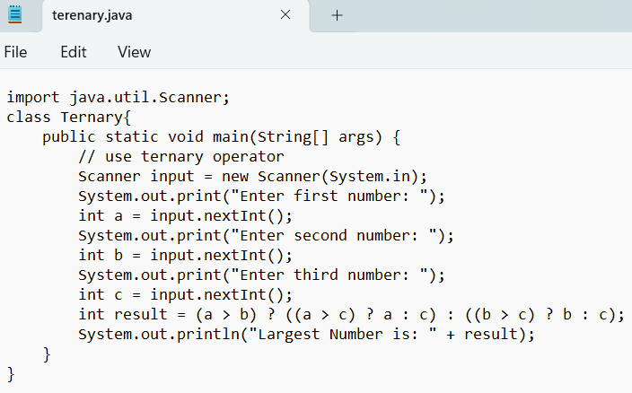**Output:**

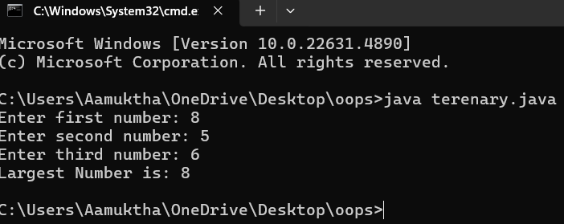

**Error:**

|  |  |  |
| --- | --- | --- |
| **Sno.** | **Error message** | **Error rectification** |
| 1. | error: ';' expected  int result=(a>b) ((a>c)? a:c) : ((b>c)? b:c);  error: not a statement  int result=(a>b) ((a>c)? a:c) : ((b>c)? b:c); | Add a ‘?’  int result=(a>b)? ((a>c)? a:c) : ((b>c)? b:c); |
| 2. | error: ';' expected  int result=(a>b)? ((a>c)? a:c) : ((b>c)? b:c) | Add a ‘;’  int result=(a>b)? ((a>c)? a:c) : ((b>c)? b:c); |

**Concepts to be known:**

1. import java.util.Scanner; - To accept input from user, Scanner class under util package has to be imported.
2. Scanner input=new Scanner(System.in); - Used to create a Scanner object
3. int a=input.nextInt (); - Used to read integer data type stored under the object created
4. int result=(a>b)? ((a>c)? a:c) : ((b>c)? b:c); - Nested Ternary operator is used here.

Syntax for ternary operator is- condition? expression 1: expression 2; , whose answer is stored in a variable and then used.

**Program 5**

**Aim:** Write a java program to find the factorial of a number.

**Code:**

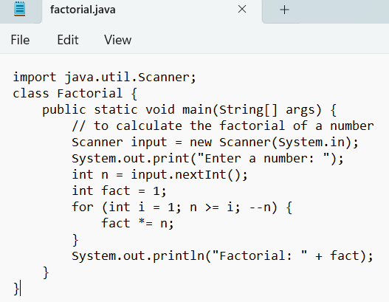

**Output:**

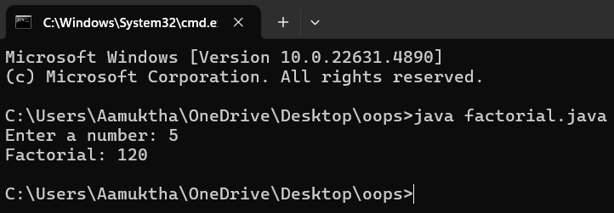

**Error:**

|  |  |  |
| --- | --- | --- |
| **Sno.** | **Error message** | **Error rectification** |
| 1. | error: ';' expected  fact*=n | Add a “;”  fact*=n; |

**Concepts to be known:**

1. for (int i=1; n>=i;--n){ } - For loop syntax: for(initial expression; test expression; update expression){} The loop is executed, until the test expression evaluates to be false.

**WEEK 3**

**Program 1**

**Aim:** To create a java program with the following instructions:

1. Create a class with name “Car”
2. Create 4 attributes, named: car_color, car_brand, fuel_type, mileage
3. Create 3 methods, named: start(), service(), stop()
4. Create 3 objects, named: car1, car2, car3
5. Create a constructor, which should print, “Welcome to car garage” .

**Class Diagram:**

|  |
| --- |
| Car |
| + car_color: String  + car_brand: String  + fuel_type: String  + mileage: int |
| + Car(): void  + start(): void  + service(): void  + stop(): void |

**Code:**

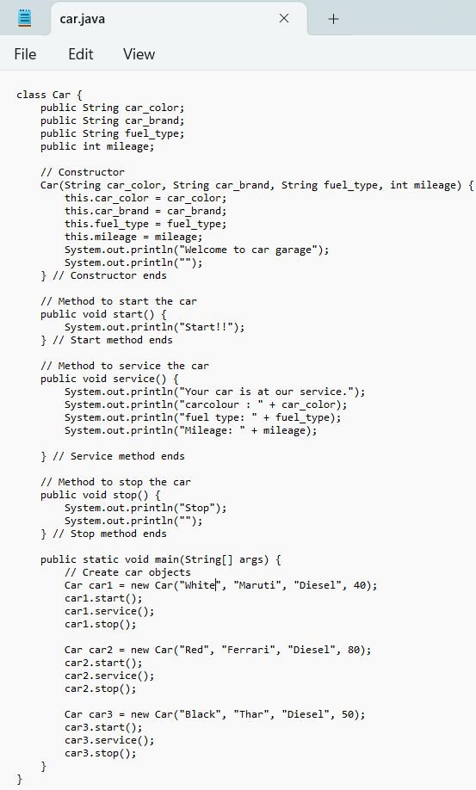

**Output:**

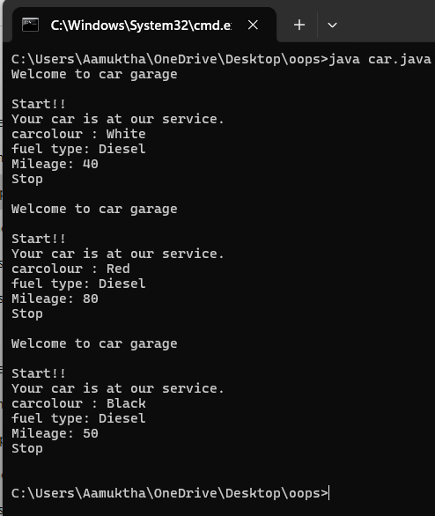

**Error:**

|  |  |  |
| --- | --- | --- |
| **Sno.** | **Error message** | **Error rectification** |
| 1. | error: ';' expected  car1.start() | Add a “;”  car1.start(); |
| 2. | error: illegal start of type  public void stop({ | Add a “)”  public void stop(){ |
| 3. | error: cannot find symbol thiscar_brand=car_brand; | Add a “.”  this.car_brand=car_brand; |

**Concepts to be known:**

1. public String car_color; - Used to declare a variable named car_color, with data type as String with public accessibility.
2. Car(String car_color,String car_brand,String fuel_type,int mileage){ } – It is a constructor (method with name same as class), which requires parameters such as car_color (String data-type) and so on.
3. this.car_color=car_color; - “this” is a default method, which is used to point to the instance variables.
4. public void start(){} – used to declare a method, which will return nothing(void) in public accessibility.

**Program 2**

**Aim:** To write a java program to create a class named BankAccount, with 2 methods deposit() and withdraw().

1. deposit(): Whenever an amount is deposited, it has to be update the current amount.
2. withdraw(): Whenever an amount is withdrawn, it has to be less than the current amount , else print (“Insufficient funds”)

**Class Diagram:**

|  |
| --- |
| BankAccount |
| - name: String  - Accno: int  - CurrBal: int |
| BankAccount: void  + withdraw(int WAmt): void  + deposit(int DAmt): int |

**Code:**

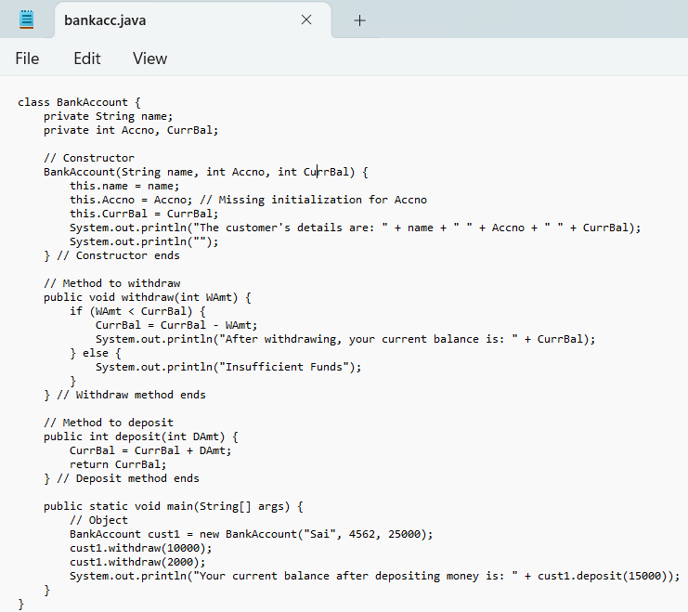

**Output:**

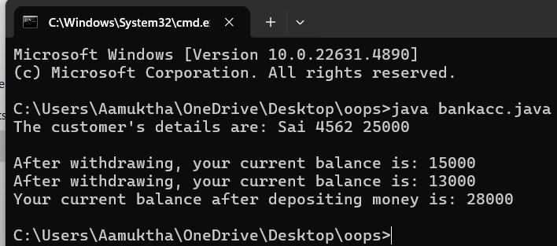

**Error:**

|  |  |  |
| --- | --- | --- |
| **Sno.** | **Error message** | **Error rectification** |
| 1. | error: ';' expected cust1.withdraw(3050) | Add a “;”  cust1.withdraw(3050); |
| 2. | error: cannot find symbol thisCurrBal=CurrBal; | Add a “.”  this.CurrBal=CurrBal; |

**Concepts to be known:**

1. private String name; - Used to declare a variable named name, with data type as String with private accessibility.
2. BankAccount(String name,int Accno,int CurrBal){ } – It is a constructor (method with name same as class), which requires parameters such as name (String data-type) and so on.
3. this.CurrBal=CurrBal; - “this” is a default method, which is used to point to the instance variables.
4. public void withdraw(int WAmt){ } – used to declare a method, which will return nothing(void) in public accessibility, which requires a parameter WAmt(integer data type).
5. public int deposit(int DAmt){} - used to declare a method, which will return integer data type in public accessibility, which requires a parameter DAmt(integer data type).
6. BankAccount cust1=new BankAccount("Ram",5587,20000); - used to create a object in class BankAccount, with object name as cust1.

**WEEK 4**

**Program 1**

**Aim:** Write a java program with class named “book”, the class should contain various attributes such as title, author, year of publication it should also contain a constructor with parameters which initializes, title, author, and year of publication.

Create a method which displays the details of the book and display the details of two books.

**Class Diagram:**

|  |
| --- |
| Book   * Title: String * Author: String * Year of publication: int   + Book(title: String,  Author: String;  Year of publication: int  + displayDetails( ): void |

**Code:**

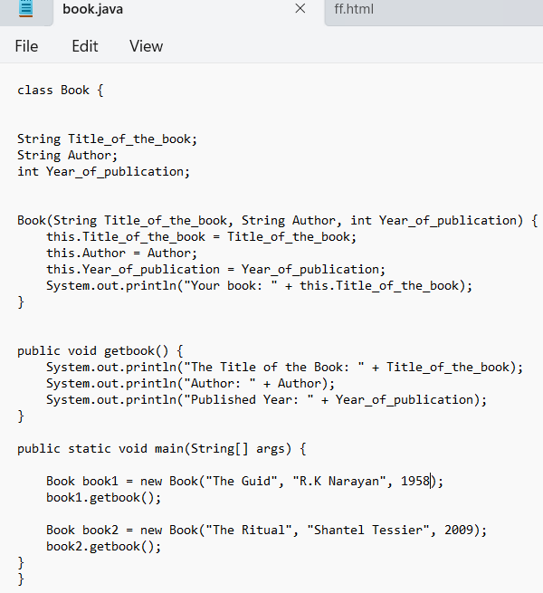

**Output:**

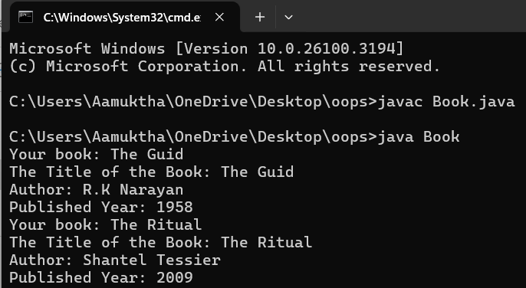

**Error Table:**

|  |  |  |
| --- | --- | --- |
| **Sno.** | **Error Message** | **Error rectification** |
| 1. | System.out.println(" Your book: "+this Title_of_the_book); - Syntax error | Change this Title_of_the_book to this.Title_of_the_book. |
| 2. | book.getbook(); - Error in calling method | Replace book.getbook(); with book1.getbook(); and book2.getbook();. |
| 3. | book book1 = new book("The Guid", "R/K Narayan", 1958); - Class name issue | Change book to Book everywhere in the file |

**Important points:**

1. (public Book(String titleOfTheBook, String author, int yearOfPublication)):
2. This method initializes the attributes of the Book class when an object is created.
3. It ensures that all necessary details (title, author, year of publication) are provided when creating a new book object.
4. Public String getTitle():Return the title of the book.
5. Public String get()Author(): the author of the book.
6. Public String getYearOfPublication():Return the year of publication of the book.
7. public void getBook(): This method prints out the details of the book, including its title, author, and year of publication

**Program 2**

**Aim:** Create a java Program with class named myclass with static variable count of int type, initialized to zero and a constant variable “pi” of type double initialized to 3.14 as attributes of the class, ow define a constructor for “myclass” that increments the count variable each time an object of my class is created (count++), finally print the final values of count and pi variables create three objects.

**Class Diagram:**

|  |
| --- |
| Myclass   * Count: int * Pi: double   + myclass( )  + main(args: String[]): void |

**Code:**

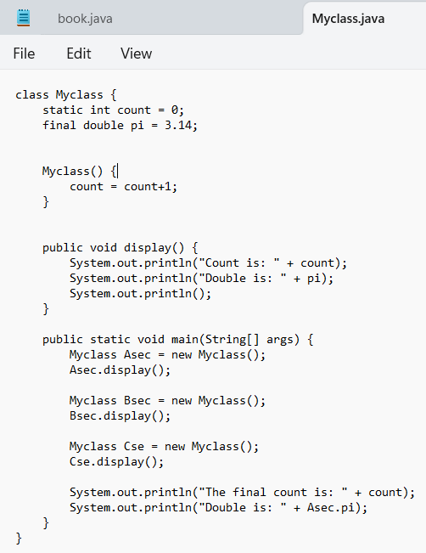

**Output:**

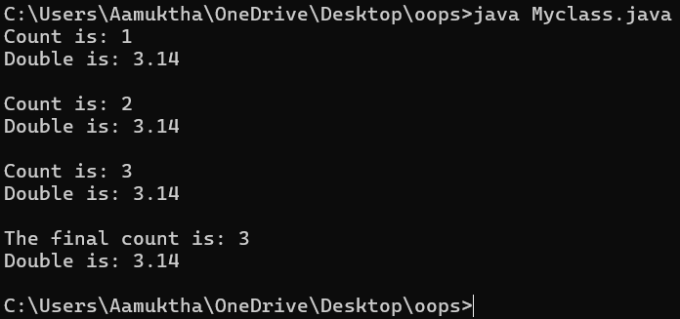

**Error Table:**

|  |  |
| --- | --- |
| **Code Error** | **Code rectification** |
| 1. Not Putting the semi-colon after calling a function, 2. Not giving the indentation properly. | 1. Put the semi-colon after calling a function. 2. All the indentation must be correct to run the code correct. |

**Important points:**

1. Asec.display() and Bsec.display() access the instance methods and variables through their respective object references.
2. System.out.println(“Double is :”+Bsec.pi); accesses that pi variable of the Bsec object.
3. new keyword followed by the class constructor. This allocates memory for the object and initializes its attributes.
4. new is necessary for creating objects and invoking constructors.
5. Object References are needed to access instance variables and methods.
6. final double pi means that once pi is initialized with the value 3.14, it cannot be changed.

**WEEK 05**

**PROGRAM-1:**

**AIM:** Create a calculator using the operations including addition, subtraction, multiplication, and division using multi-level inheritance and display the desired output.

Hint: collect required variables using super class, create each class for a parameter and each class must contain a method.

**CLASS DIAGRAM:**

|  |
| --- |
| Calculator |
| * a : double * b : double |
| + Calculator (a,b) |

|  |
| --- |
| Addition |
| + add() : double |

|  |
| --- |
| + add() : double |

|  |
| --- |
| Subtraction |
| + subtract() : double |

|  |
| --- |
| Multiplication |
| + multiply() : double |

|  |
| --- |
| + add() : double |

|  |
| --- |
| Divison |
| +divide() : double |

**CODE:**

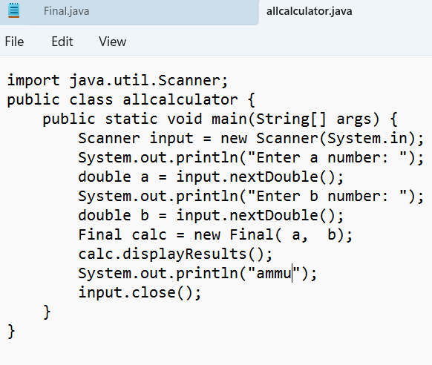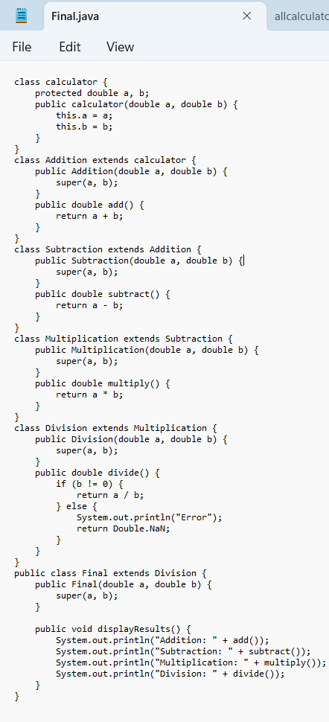

**OUTPUT:**

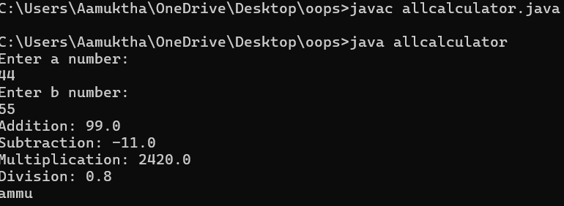

**ERRORS:**

|  |  |
| --- | --- |
| **Code Error** | **Code rectification** |
| 1. not providing the return method correctly. 2. Not mentioning super to obtain the super class constructor. | 1. After declaring methods, we must provide the return method correctly. 2. To obtain the super class we need to mention super. |

**IMPORTANT POINTS:**

1. To get the inputs from the user we use import java.util.Scanner; this is a package.
2. Scanner class is used to get the user input.
3. In java.util.Scanner, the java.util is a package while Scanner is a class of the java.util package.
4. To import a whole package, end the sentence with an asterisk sign(*).

**PROGRAM-2:**

**AIM:** A vehicle rental company wants to develop a system that maintains information about different types of vechicles available for rent the company rents out cars and bikes, and they need a program to store details about each vehicle, such as brand and speed( should be in super class)

1. cars should have an additional property: no.of doors
2. Bikes should have a property indicating whether they have gears or not.
3. The system should also include a function to display details about each vehicle and indicate when a vehicle is starting.
4. Every class should have a constructor

**Question:**

1. Which oops concept is used in the above program
2. If the company decides to add a new type of vehicle, Truck, how would you modify the program?
3. Truck should include an additional property capacity (in tons)
4. Create a showTruckdetails() method to display the truck’s capacity.
5. Write a constructor for Truck that initializes all properties
6. Implement the truck class and update the main method to create a Truck object and also create an object for car and bike sub classes Finally, display the details.

**IMPORTANT POINTS:**

1. a constructor helps in initializing an object that doesn't exist.
2. a method performs functions on pre-constructed or already developed objects.
3. a double method can represent more decimal point numbers than float method.
4. the void keyword in java is used to specify that a method does not return any value. it is a return type that indicates the method performs a function and doesn't produce a result.

**Answer for Q1:**

The oops concepts used in the above program are: Inheritance, encapsulation, polymorphism, abstraction.

**CLASS DIAGRAM:**

|  |
| --- |
| Vehicle |
| -Brand : string  -Speed: int |
| + init (brand, speed)  + start_vehicle()  + display_details() |

|  |
| --- |
| Car |
| -no.of.doors:int |
| +int (brand, speed,  No.of doors);  +display deatails(); |

|  |
| --- |
| Bikes |
| -has gears:bool |
| +int (brand, speed,  has gears);  +display deatails(); |

|  |
| --- |
| Truck |
| -Capacity:float |
| -Show truck detais();  +display deatails(); |

**CODE:** 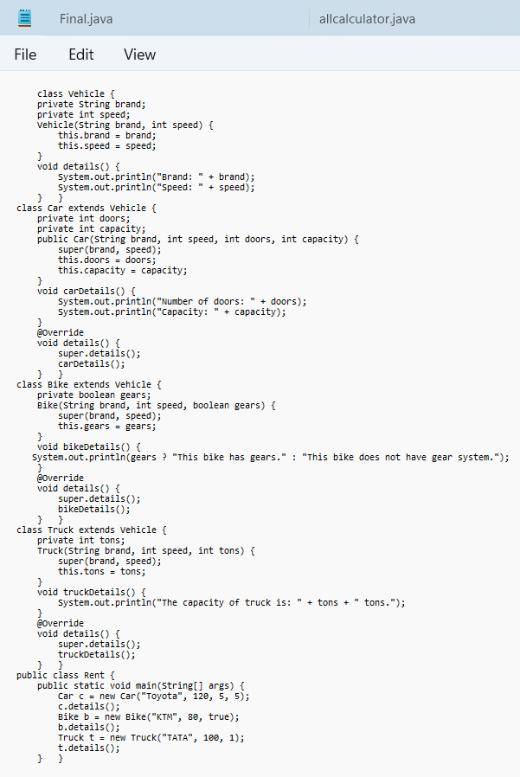

**OUTPUT:**

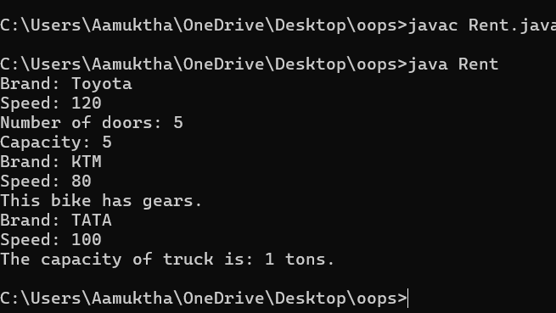

**ERROR TABLE:**

|  |  |
| --- | --- |
| Code Error | Code rectification |
| 1. Declaring two superclasses inside the same file. 2. Not declaring the variable using ‘this’ keyword inside the constructor. | 1. Make two separate files to save the two super classes. 2. Declare the variable using this keyword to run the program. |

**IMPORTANT POINTS:**

1. Base Class: calculator is the base class with protected variables a and b.
2. Inheritance Chain: Each operation class (Addition, Subtraction, Multiplication, Division) extends the previous one, forming a multi-level inheritance hierarchy.
3. Addition Class: Implements add() method to return the sum of a and b.
4. Subtraction Class: Extends Addition and adds subtract() method.

**WEEK-06**

**PROGRAM-1:**

**AIM:** Write a java program to create a vehicle class with a method displayinfo(). Override this method in the car subclass to provide specific information about car (car company, seating capacity, petrol or not).

**CLASS DIAGRAM:**

|  |
| --- |
| **Vehicle** |
| * Brand: String * Speed: int |
| + vehicle(brand: string  Speed: int)  +start vehicle(): void  +displaydetails():void |

**CODE:**

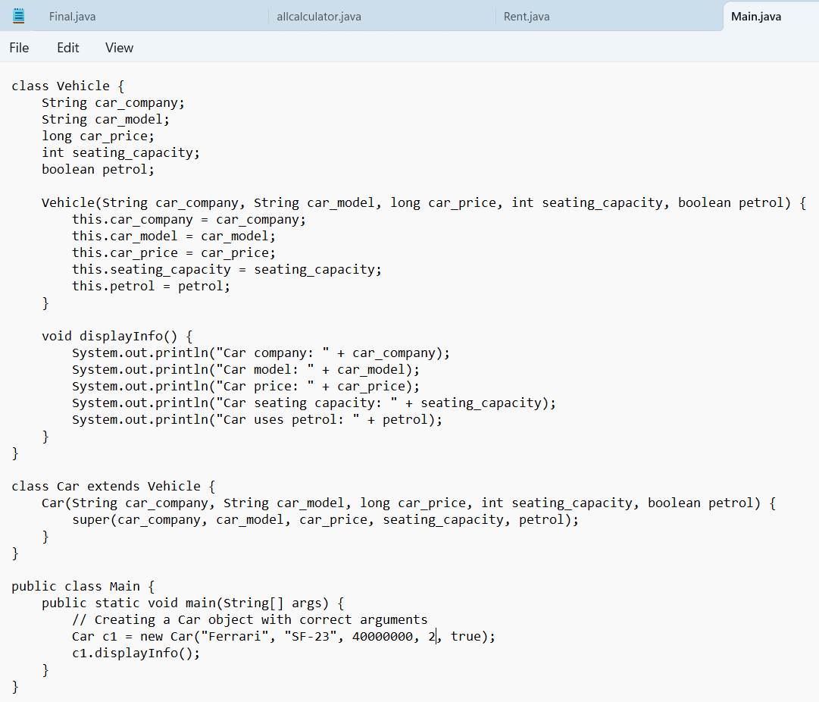**CODE:**

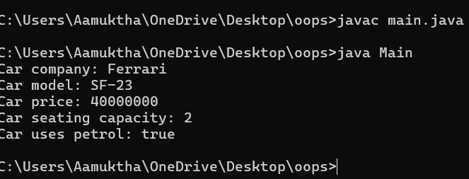

**ERRORS:**

|  |  |
| --- | --- |
| **Code error** | **Code rectification** |
| 1. Incorrect class name for main method(Truck).  2. Inconsistent car model output in displayinfo(). | 1.Rename Truck to Main or place main inside car or vehicle.  2. Ensure Car correctly passes Toyota” to super(car_model,color,fueltype) |

**IMPORTANT POINTS:**

**1.Inheritance:** The Car class extends the Vehicle class, demonstrating inheritance in Java.

**2.Constructor Chaining:** The Car class calls the parent constructor using super(car_model,color, fuel_type); to initialize inherited attributes.

**3.Method Overriding:**The Car class overrides the displayInfo() method from Vehicle and calls super.displayInfo() to reuse the parent method before adding its own output**.**

**4.Incorrect main Class Name:**The main method is inside Truck, which is unrelated to Vehicle and Car. The class should be renamed for clarity.

**PROGRAM-2:**

**AIM:** A college is developing an automated admission system that verifies students eligibility(UG) and postgraduation(PG) programs. Each program hasdifferent eligibility criteria based on the students percentage in their previous qualification.

1. UG admission recquire a minimum of 60%.

2. PG admission recquire a minimum of 70%.

**CLASS DIAGRAM:**

|  |
| --- |
| **AutomatedAdmission** |
| * Scanner: scanner * Name: String * Percentage : double * Program: stirng |
| + main(args:String[]): void  +takeInput(): void  +checkEligibility(): void  +closeScanner(); void |

**CODE:**

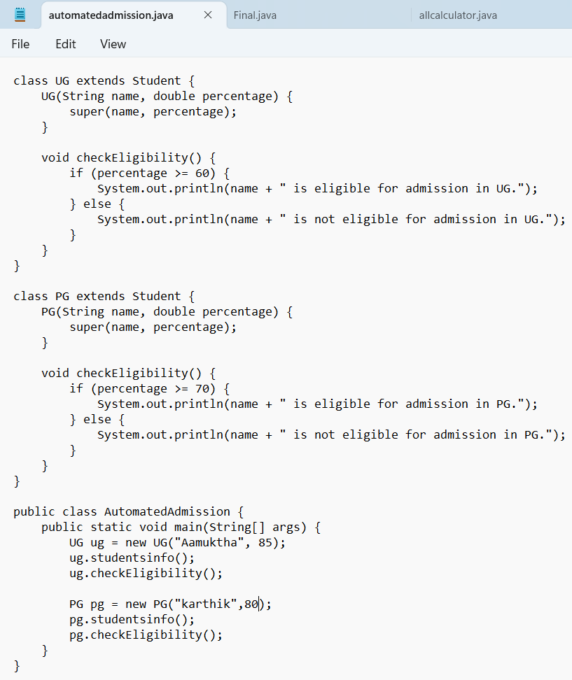

**OUTPUT:**

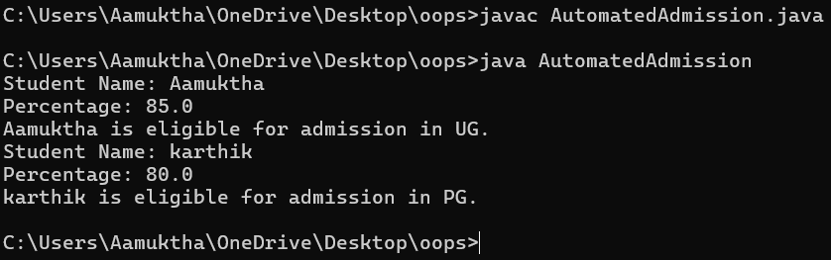

**ERRORS:**

|  |  |
| --- | --- |
| **Code error** | **Code rectification** |
| **1.Scanner nextLine() issue after nextDouble():** After scanner.nextDouble(), the newline character remains in the buffer, causing nextLine() to be skipped.  **2.Program type input case sensitivity issue**: If the user enters ug or pg in lowercase, it may cause incorrect comparisons. | **1**.Add scanner.nextLine(); after nextDouble(); to consume the leftover newline.  **2.**Use program.toUpperCase() to ensure case-insensitive comparison. |

**IMPORTANT POINTS:**

**1.User Input Handling:** Uses Scanner to take user input for name, percentage, and program type.

**2.Decision Making with Conditions:** Uses if-else statements to check eligibility criteria.

**3.String Handling:** Converts program input to uppercase (toUpperCase()) to handle case variations.

**4.Closing Scanner:** Properly closes scanner using scanner.close(); to prevent resource leaks.

**PROGRAM-3:**

**AIM:** Create a calculator class with overloaded methods to perform addition of:

1. Add two integers

2. Add two doubles

3. Add three integers

**CLASS DIAGRAM:**

|  |
| --- |
| **Calculator** |
| + add(int, int): int  +add(double, double): double  +add(int,int,int): int |

**CODE:**

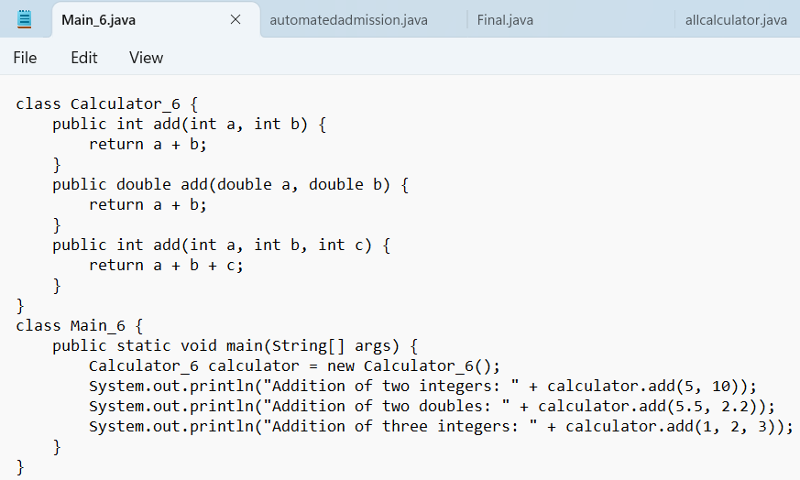

**OUTPUT:**

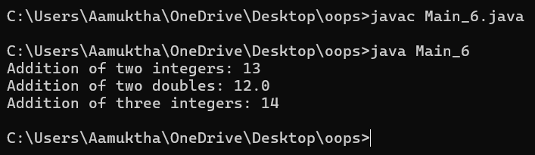

**ERRORS:**

|  |  |
| --- | --- |
| **Code error** | **Code rectification** |
| 1.Method parameters missing spaces. E.g.,”inta, intb”should be “int a, int b”  2.Inconsistent indentation in method bodies | 1**.** Add proper spacing between parameters: (int a, int b)  2.Fix indentation:  Consistent 4 space o indentation. |

**IMPORTANT POINTS:**

**1.Method Overloading:** The add method is overloaded with different parameter types and counts, demonstrating compile-time polymorphism.

**2.Automatic Method Selection:** Java selects the appropriate add method based on the argument types during compilation.

**PROGRAM-4:**

**AIM:** Create a shape class with a method to calculate area i.e., overloaded for different shapes eg: Squares, Recatangle. Then create a subclass circle that overrides the calculateArea() method for a circle.

**CLASS DIAGRAM:**

|  |
| --- |
| **SHAPE** |
| + CalculateArea(side:double): double  +CalculateArea(width: double, length: double): double |

|  |
| --- |
| **CIRCLE** |
| + CalculateArea(radius: double): double |

|  |
| --- |
| **Tools** |
| +main(args:String[]): Void |

**CODE:**

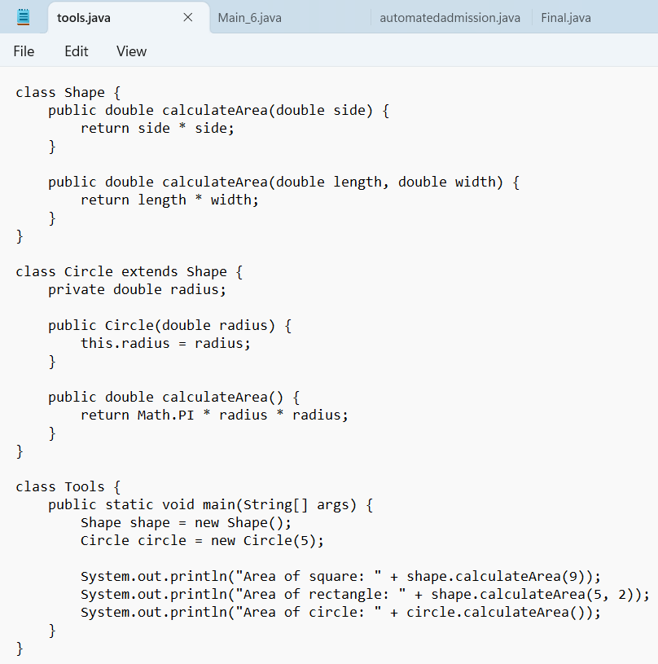

**OUTPUT:**

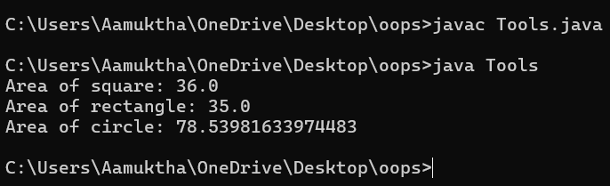

**ERRORS:**

|  |  |
| --- | --- |
| **Code error** | **Code rectification** |
| 1. Method calls in main are missing an object reference (e.g., calculateArea(4) instead of s.calculateArea(4)).  2. Circle class method does not override theparent class method properly. | 1. Use s.calculateArea(4) and c.calculateArea(2) to call the method correctly.  2. Ensure @Override is used, and the method signature should match correctly. |

**IMPORTANT POINTS:**

**1.Inheritance:** Circle class extends Shape, inheriting its methods.

**2.Method Overloading:** Shape has multiple calculateArea methods with different parameters.

**3.Method Overriding:** Circle overrides calculateArea from Shape to implement its own formula**.**

**4.Polymorphism:** The overridden method in Circle demonstrates runtime polymorphism.

**5.Proper Object Reference:** Methods should be called using an object (s.calculateArea(4), c.calculateArea(2)).

**WEEK – 07**

**PROGRAM1**

**AIM:** create a Java program to create an abstract class animal with an abstract method called sound ().Create a subclass Lion and tiger that extend the Animal class and implement the sound () method to make a specific sound for each animal**.**

|  |
| --- |
| **<<abstract>>**  **ANIMAL** |
| + sound(): void |

**CLASS DIAGRAM:**

|  |
| --- |
| **LION** |
| + sound(): void |

|  |
| --- |
| **TIGER** |
| + sound(): void |

**CODE:**

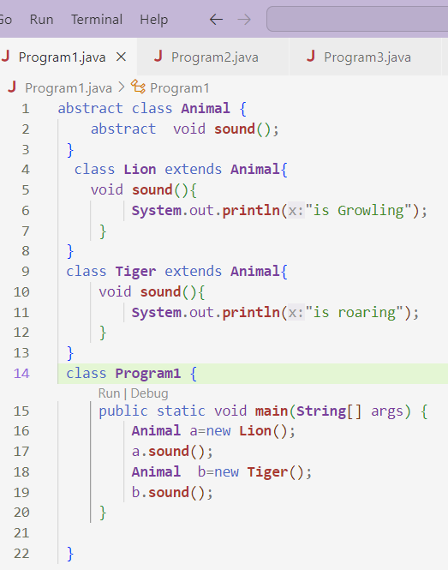

**OUTPUT:**

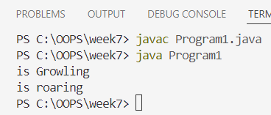

**ERRORS:**

|  |  |
| --- | --- |
| **Code error** | **Code rectification** |
| 1. Forgetting to use abstract keyword for the sound() method.  2 Not overriding the sound() method in subclasses. | 1. Rectified as abstract void sound();  2. Added void sound() { ... } in each subclass. |

**IMPORTANT POINTS:**

1. Animal is an abstract class with an abstract method sound().
2. Lion and Tiger classes extend Animal and override sound().
3. Abstract methods must be implemented in child classes.
4. Abstract classes cannot be instantiated directly.
5. Method overriding allows each subclass to define its own version of sound()

**PROGAM 2**

**AIM:** Write a Java program to create an abstract class shape 3D with abstract methods calculate volume ()and calculate surface Area ()create subclasses Sphere and cube that extend the Shape 3D class and implement the respective methods to calculate volume and surface area of each shape.

**CLASS DIAGRAM:**

|  |
| --- |
| **<<abstract>>**  **SHAPE 3D** |
| +calculateVolume():double +calculateSurface():double |

|  |
| --- |
| **SPHERE** |
| - radius: int |
| +calculateVolume(): double  +calculateSurface():double |

|  |
| --- |
| **CUBE** |
| - side: int |
| +calculateVolume():double  +calculateSurface():double |

**CODE:**

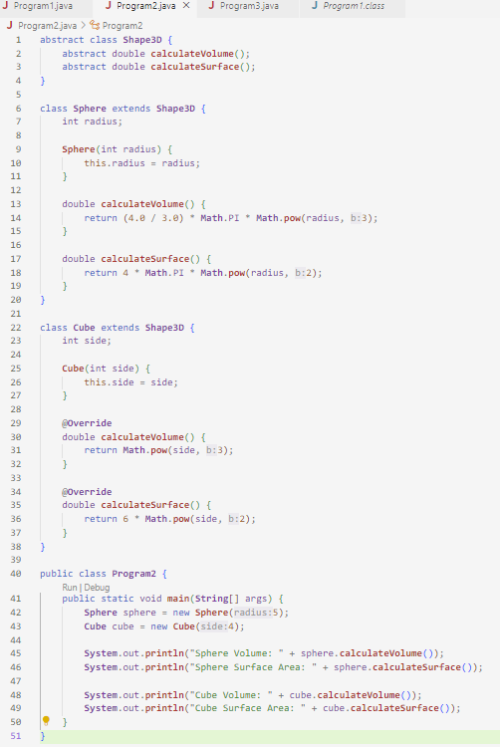

**OUTPUT:**

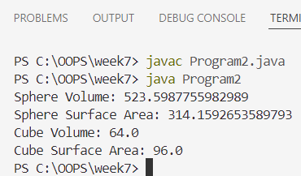

**ERRORS:**

|  |  |
| --- | --- |
| **Code error** | **Code rectification** |
| |  | | --- | |  |  |  |  |  |  |  |  |  |  |  |  |  |  |  | | --- | --- | --- | --- | --- | --- | --- | --- | --- | --- | --- | --- | --- | | 1. int used instead of double for Volume surface.   |  |  |  | | --- | --- | --- | | 2.(4 / 3) used instead of (4.0 / 3.0). | | | | 3.14 used as approximation for π. | | |  | | | |  |  | | | | |  |  |  |  | | --- | |  |  |  | | --- | |  | | 1. Changed return types of calculateVolume() and calculateSurface() to double 2. Used floating-point division to avoid integer division loss. 3. 3.Used Math.PI for more accurate calculations. |

**IMPORTANT POINTS:**

* Shape3D is an abstract class with two abstract methods: calculateVolume() and calculateSurface().
* Sphere and Cube classes extend Shape3D and provide specific implementations.
* Sphere Volume: (4/3) * π * radius³ using Math.pow(radius, 3).
* Sphere Surface Area: 4 * π * radius² using Math.pow(radius, 2).

**PROGRAM 3**

**AIM:** Write a Java program using an abstract class to define a method for pattern printing.

Create an abstract class named PatternPrinter with:

* An abstract method printPattern(int n)
* A concrete method to display the pattern title

Create two subclasses:

1.StarPattern: Prints a right-angled triangle of stars (*)

2.NumberPattern: Prints a right-angled triangle of increasing numbers

In the main() method, create objects of both subclasses and print the patterns for a given number of rows.

|  |
| --- |
| **<<abstract>> PatternPrinter** |
| +displayTitle(title)  +printPattern(n) |

**CLASS DIAGRAM:**

|  |
| --- |
| **StarPattern** |
| +Printpattern (n) |

|  |
| --- |
| **NumberPattern** |
| +Printpattern (n) |

**CODE:**

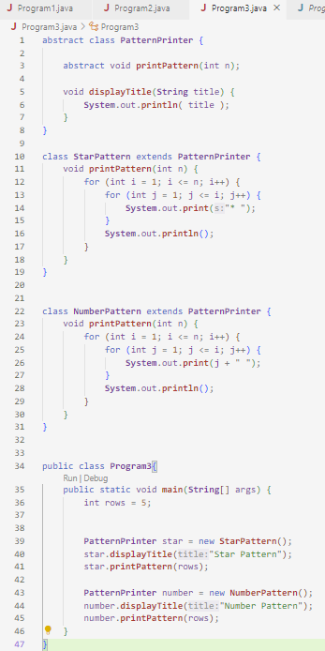

**OUTPUT:**

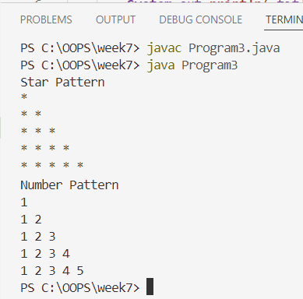

**ERRORS:**

|  |  |
| --- | --- |
| **Code error** | 1. **Code rectification** |
| |  | | --- | |  |  |  |  | | --- | --- | | 1.Wrong loop logic ( printing * without loop). | | |  |  |  |  |  |  |  |  | | --- | --- | --- | --- | --- | | |  |  |  | | --- | --- | --- | | |  | | --- | | 2.displayTitle method not used before pattern printing |  |  | | --- | | 3.Forgot to implement printPattern(int n) in subclass | | | | |  |  |  |  | | --- | |  |  |  | | --- | |  | | 1.Use nested loops: outer loop for rows, inner loop for printing symbols or numbers.  2.Call displayTitle() before printing the pattern for proper formatting  3.Implemented the method in both subclasses |

**IMPORTANT POINTS:**

1.PatternPrinter is an abstract class with an abstract method printPattern(int n).

2.It also has a concrete method displayTitle(String title) to print a title.

3.StarPattern and NumberPattern extend PatternPrinter and implement printPattern().

4.StarPattern prints a right-angled triangle using "*" characters.

**WEEK – 8**

**PROGRAM-1:**

**AIM:** Write a java program shape with get perimeter() method and create three class rectangle circle triangle that implement the shape interface and implement the get perimeter for all the 3 classes.

**CLASS DIAGRAM:**

|  |
| --- |
| **<<interface >> SHAPE** |
| + getPerimeter(): double |

|  |
| --- |
| **Rectangle** |
| - length: double  - width: double |

|  |
| --- |
| **Circle** |
| - radius: double |

|  |
| --- |
| + getPerimeter(): double |

|  |
| --- |
| **Triangle** |
| - side1: double  - side 2: double  - side 3: double |

|  |
| --- |
| + getPerimeter(): double |

|  |
| --- |
| + getPerimeter(): double |

**CODE:**

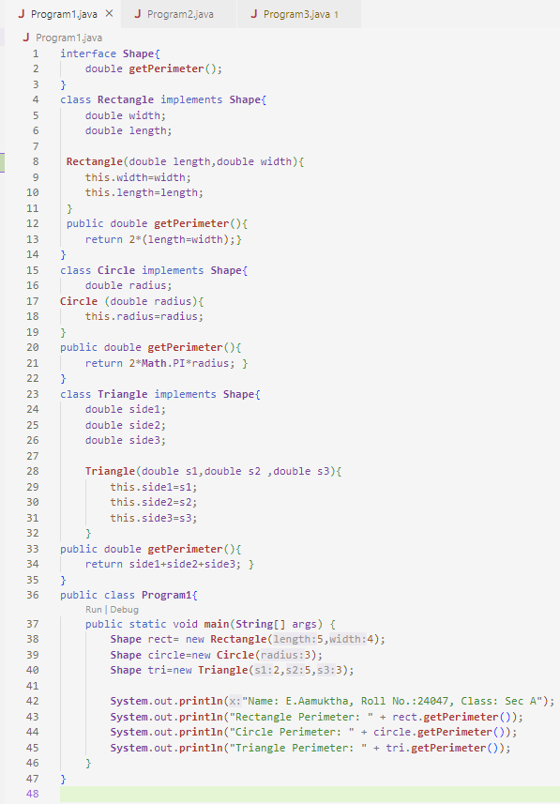

**OUTPUT:**

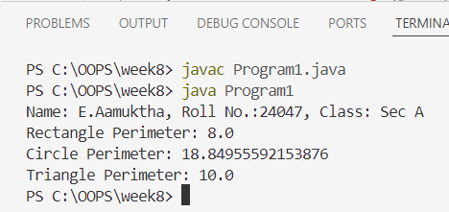

**ERRORS:**

|  |  |
| --- | --- |
| **Code error** | **Code rectification** |
| 1. Missed Math.PI in Circle perimeter,  2.Did not give meaningful class name. | 1. Rectified to Math.PI in Circle perimeter. 2. Rectified |

**IMPORTANT POINTS:**

* Uses an interface Shape with a method getPerimeter().
* Implements Shape in Rectangle, Circle, and Triangle classes.
* Demonstrates polymorphism by referencing different shapes via the Shape interface.
* Contains a bug in Rectangle's perimeter calculation (uses length = width instead of length + width).

**PROGRAM – 2**

**AIM: :** java program to create an interface playable with method play() that takes no argurments and return void create subclasses volleyball basketball football that implements playabale interface and override the play.

**CLASS DIAGRAM:**

|  |
| --- |
| **<<interface>>**  **Playable** |
| + play(): void |

|  |
| --- |
| **Volleyball** |
| + play(): void |

|  |
| --- |
| **Football** |
| + play(): void |

|  |
| --- |
| **Basketball** |
| + play(): void |

**CODE:**

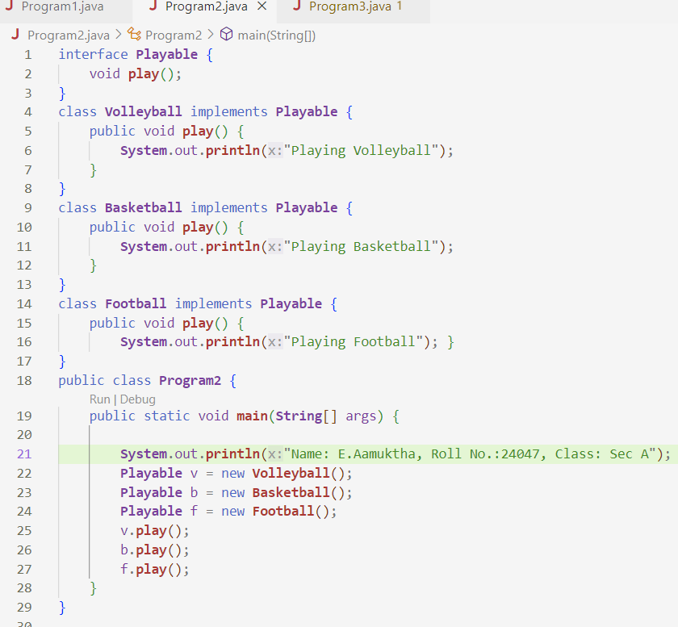

**OUTPUT:**

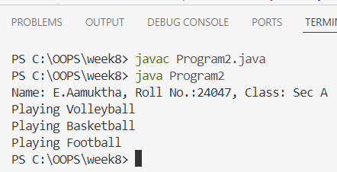

**ERRORS:**

|  |  |
| --- | --- |
| **Code error** | **Code rectification** |
| 1.Wrote System.out.println(play);  2. forgot public in Method play()   |  | | --- | |  | | 1.Rectified to v.play();  2.used public void play() in all implementing classes |

**IMPORTANT POINTS:**

* Interface Usage – Playable interface defines a play() method.
* Implementation – Volleyball, Basketball, and Football all implement Playable.
* Polymorphism – Different objects are referenced using the Playable interface.
* Correct Output Method – play() is called using the object, not printed directly.

**PROGRAM-3**

**AIM:** Write a java program to create a login system using interface.

**CLASS DIAGRAM:**

|  |
| --- |
| <<interface>>  LoginSystem |
| + login(): void |

|  |
| --- |
| UserLogin |
| **-** correctUsername: String  - correctPassword: String |
| + login(): void |

**CODE:**

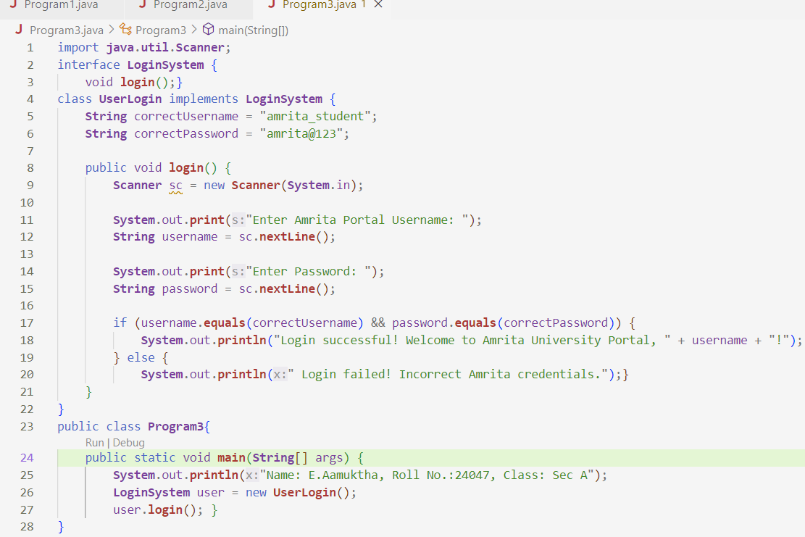

**OUTPUT:**

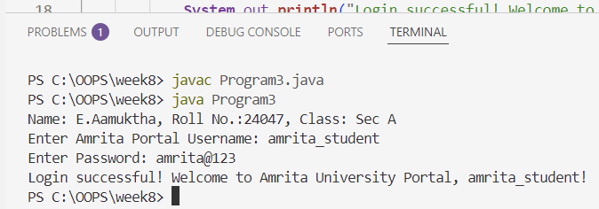**ERRORS:**

|  |  |
| --- | --- |
| **Code error** | **Code rectification** |
| 1.Forgot to use .equals() for string comparison  2. Didn't import java.util.Scanner.  3. Called user.login() with parameters   |  | | --- | |  | | 1. Used username.equals(correctUsername) not ==  2. Added import java.util.Scanner;  3. Correct is user.login(); with no parameters |

**IMPORTANT POINTS:**

* Interface LoginSystem defines a login() method.
* UserLogin class implements LoginSystem and provides logic for user authentication.
* Scanner class is used to take user input for username and password.

**WEEK-9**

**PROGRAM-1**

**AIM**: Write a java program to create a method that takes integers as parameters and throws an exception if the number is even.

**CLASS DIAGRAM:**

|  |
| --- |
| EvenNumberExceptionDemo |
| +checkoddNumber(int number): void  +main(String[]args):void |

|  |
| --- |
| EvenNumberException  (extends Exception) |
| + EvenNumberException() |

**CODE:**

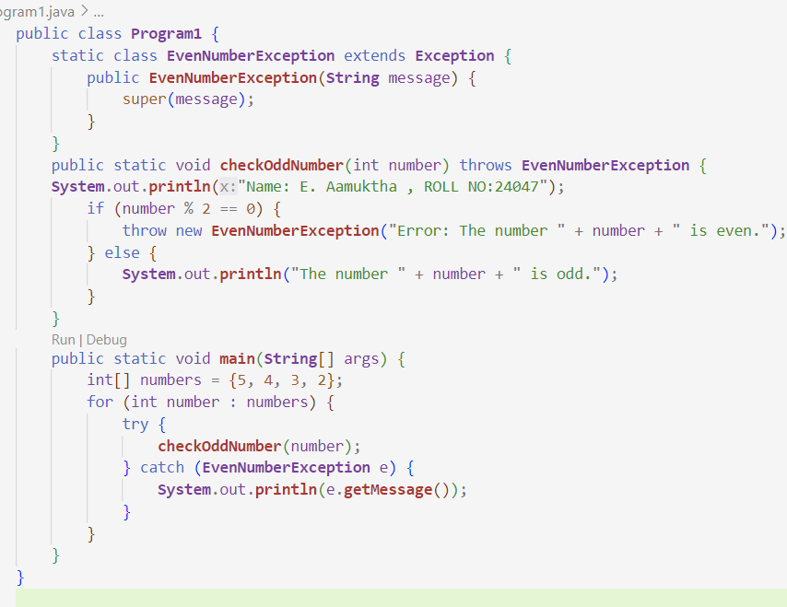

**OUTPUT:**

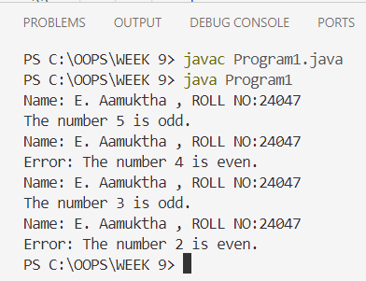

**ERRORS:**

|  |  |
| --- | --- |
| **Code Error** | **Code Rectification** |
| 1. Unhandeled exception type EvennumberException. 2. Syntax errors 3. Compilation error. | 1. If you checkoddNumber() without using try-catch or without declaring throws. 2. If missing curly barces or wrong method syntax. 3. If constructor of EvenNumberException is missing or incorrectly defined. |

**IMPORTANT POINTS:**

1. Created a custom exception by extending the Exception class.
2. Used throw keyword to manually throw the custom exception if the number is even.
3. Handled the exception using a try-catch block inside main() method.
4. Demonstrates user-defined exception handling.
5. Shows clear separation of concerns: checking number and exception message.

**PROGRAM-2**

**AIM**: Write a java program to create a method that reads a file and throws an exception if the file is not found.

**CLASS DIAGRAM:**

|  |
| --- |
| FileReadExample |
| + main(String[] args) : void |

|  |
| --- |
| Uses |
| -BuefferdReader  -FileReader  -FileNotFound  -IOException |

**CODE:**

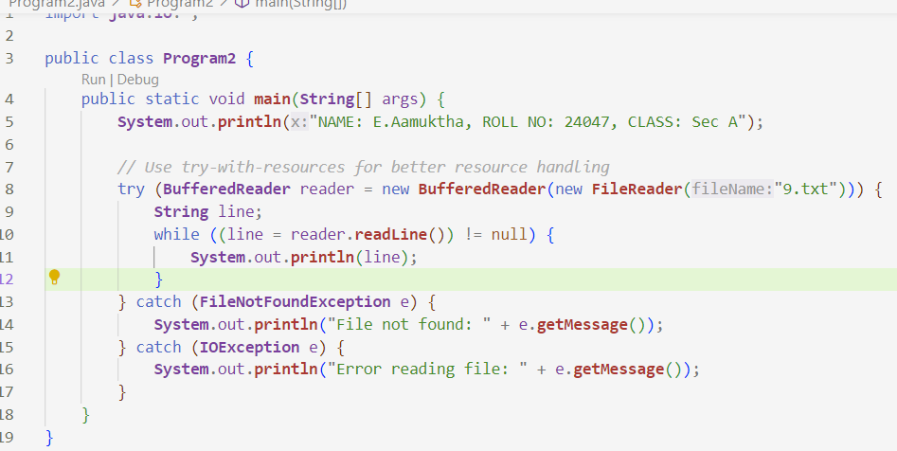

**OUTPUT:**

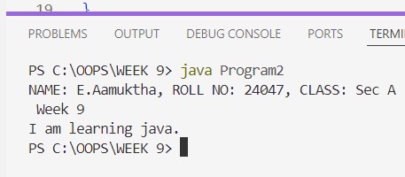

**ERRORS:**

|  |  |
| --- | --- |
| **Code Error** | **Code Rectification** |
| 1. File Not Found 2. IOException 3. Syntax Error | 1. Occurs if the specified fiole path is wrong or file does not exist. 2. Occurs while reading file if an input/output error happens. 3. If missing semicolon; wronf try-catch syntax |

**IMPORTANT POINTS:**

1. Prints Student Info: Displays your name, roll number, and class at the start.
2. File Reading: Reads content from a text file named 9.txt.
3. BufferedReader Used: Efficiently reads the file line by line.
4. Try-with-Resources: Automatically closes the file after reading

**PROGRAM-3**

**AIM:** Write a java program to handle arthimatic exception using try, catch and finally.

**CLASS DIAGRAM:**

|  |
| --- |
| FileReadExample |
| +main(String[]args): void |

|  |
| --- |
| Uses |
| -BuefferdReader  -FileReader  -FileNotFound  -IOException |

**CODE:**

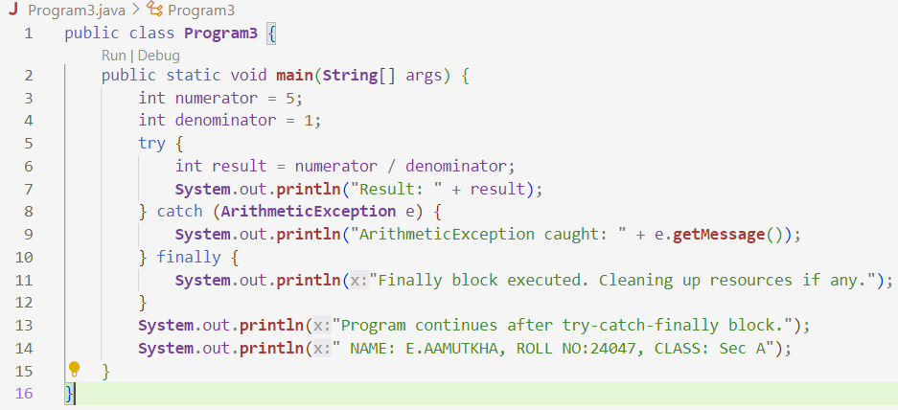

**OUTPUT:**

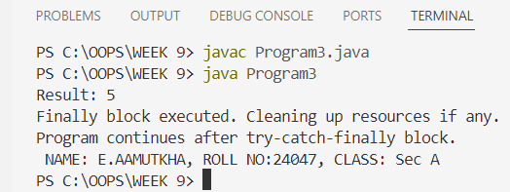

**ERRORS:**

|  |  |
| --- | --- |
| **Code Error** | **Code Rectification** |
| 1. File not found 2. IOException 3. Syntax error | 1. Occurs if the specified file path is wrong or file does not exist 2. Occurs while reading file if an input/output error happens 3. If missing semicolon ; wrong try-catch block syntax |

**IMPORTANT POINTS:**

1. Performs Division: Attempts to divide numerator (5) by denominator (1).
2. Try-Catch-Finally Structure: Demonstrates proper exception handling.
3. No Exception Thrown: Since denominator = 1, no ArithmeticException occurs.
4. Catch Block: Ready to handle division by zero, but unused here.
5. Finally Block: Always executes, prints cleanup message.

**PROGRAM-4**

**AIM**: Write a program to stimulate a university system using inner classes.

* Create an outer class named university with a variable universityName.
* Inside it, define two non-static inner classes.

1. Department- With variables like deptName, deptCode and a method to display department details.
2. Student- With variables like studentName, rollNumber and a method to display details.
3. Create an object for each class and call their methods to display their details along with their universityName.

**CLASS DIAGRAM:**

|  |
| --- |
| University |
| -universityName: String  + University(String name) |

|  |
| --- |
| Innerclass |
| - Department - deptName: String - deptCode: String  + displayDepartment(): void |

|  |
| --- |
| - Student  - studentName: String  - rollNumber: int + displayStudent(): void |

|  |
| --- |
| + main(String[] args): void |

**CODE:**

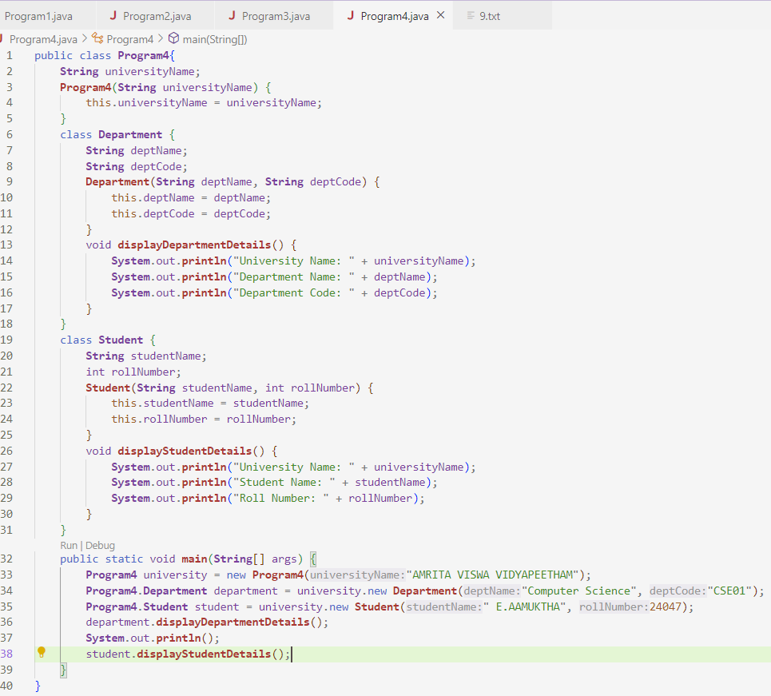**OUTPUT:**

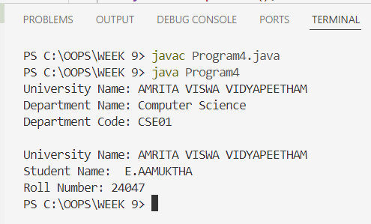

**ERRORS:**

|  |  |
| --- | --- |
| **Code Error** | **Code Rectification** |
| 1. Syntax Error 2. Compilation Error 3. Runtime Error | 1.Wrong object creation for inner class  2.Accessing outerclass members wrongly  3.Null pointerException if outer object missing |

**IMPORTANT POINTS:**

1. Outer Class Program4: Represents a university with a name.
2. Inner Class Department: Represents a department with a name and code.
3. Inner Class Student: Represents a student with a name and roll number.
4. Inner Classes Access Outer Class: Both inner classes can access universityName directly.
5. Constructor Usage: Initializes university, department, and student using constructors.

**WEEK-10**

**PROGRAM-1:**

**AIM:** Write a java program to generate a password for a student using his/her initials and age. The password displayed should be the string consists of first character of first name, middle name, lastname with age.

**CLASS DIAGRAM:**

|  |
| --- |
| **Password** |
| +first name: String  +middle name: String  +last name: String  +age: int |
| +password(): String |
| +main(String[]args): void |

**CODE:**

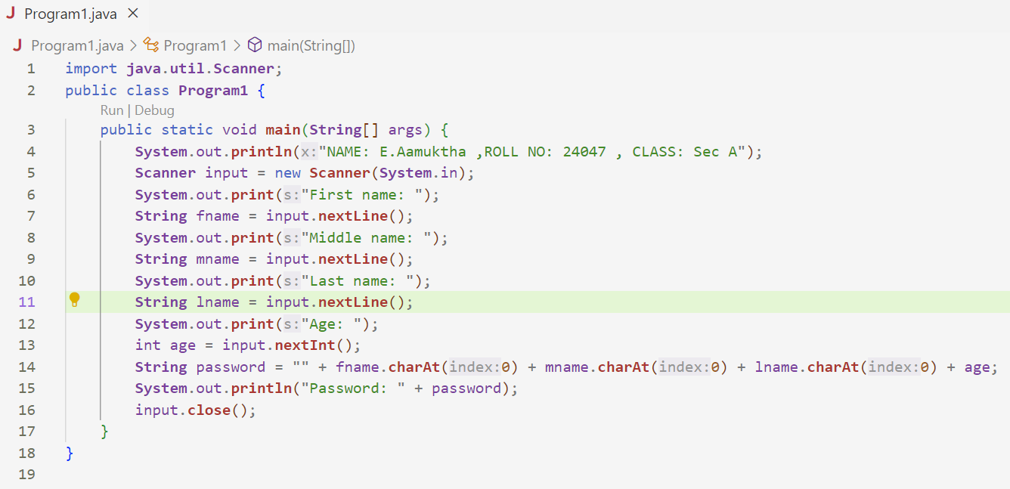

**OUTPUT:**

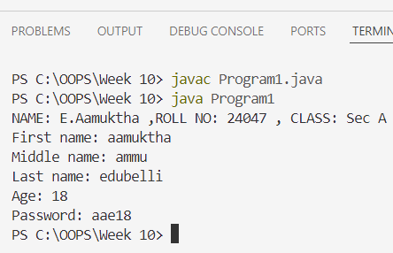

**ERRORS:**

|  |  |
| --- | --- |
| **Code Error** | **Code Rectification** |
| 1. Identifier expected after the token | Give a suitable identifier that will give the output |

**IMPORTANT POINTS:**

1. Prints student details at the start.

Takes user input for first, middle, and last name, and age using Scanner.

Extracts the first character of each name using charAt(0).

Forms a password by combining initials and age.

Displays the generated password.

**PROGRAM-2:**

**AIM:** Design and implement a java program that will do the folleing operations to this string “Welcome! You are practicing String concepts”.

* Convert all alphabets to capital letters and print out the result.
* Convert all alphabets to lowercase letters and print out the result.
* Print out the length of the string.
* Print out the index of the concept.

**CLASS DIAGRAM:**

|  |
| --- |
| **Strings** |
| +string: public  +string.uppercase()  +string.lowercase()  +string.length()  +string.index() |
| +void main(String[]args): void |

**CODE:**

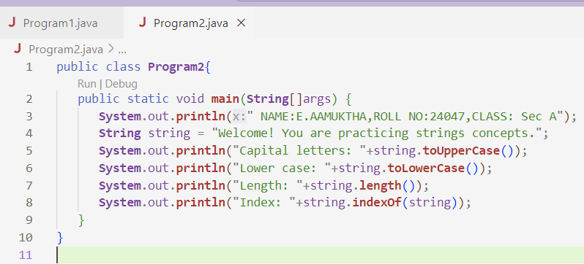

**OUTPUT:**

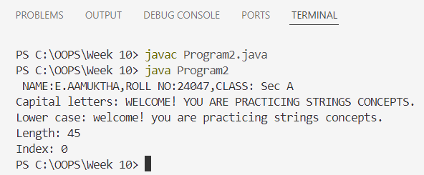

**ERRORS:**

|  |  |
| --- | --- |
| **Code Error** | **Code Rectification** |
| 1. ToUpper is undefined for the type string. | * + - 1. Type toUpperCase() instead of to uppercase() |

**IMPORTANT POINTS:**

1. Prints your name, roll number, and class.
2. Declares a string: "Welcome! You are practicing strings concepts."
3. Converts and prints the string in uppercase using toUpperCase().
4. Converts and prints the string in lowercase using toLowerCase().

**PROGRAM-3:**

**AIM:** Implement a java program using the below array methods.

* Sorting the elements (numbers & strings) of an array.
* Convert the array elements into String.
* Fill the part of an array.
* Copy the elements of one array into the other.

**CLASS DIAGRAM:**

|  |
| --- |
| **Arrays** |
| +sort(arr: T[]): void  +toString(arr: T[]): String  +fill(arr: T[], value: T): void  +fill(arr: T[], fromindex: int, toindex: int, value: T): void  +copyof(arr: T[], newLength: int): T[] |

**CODE:**

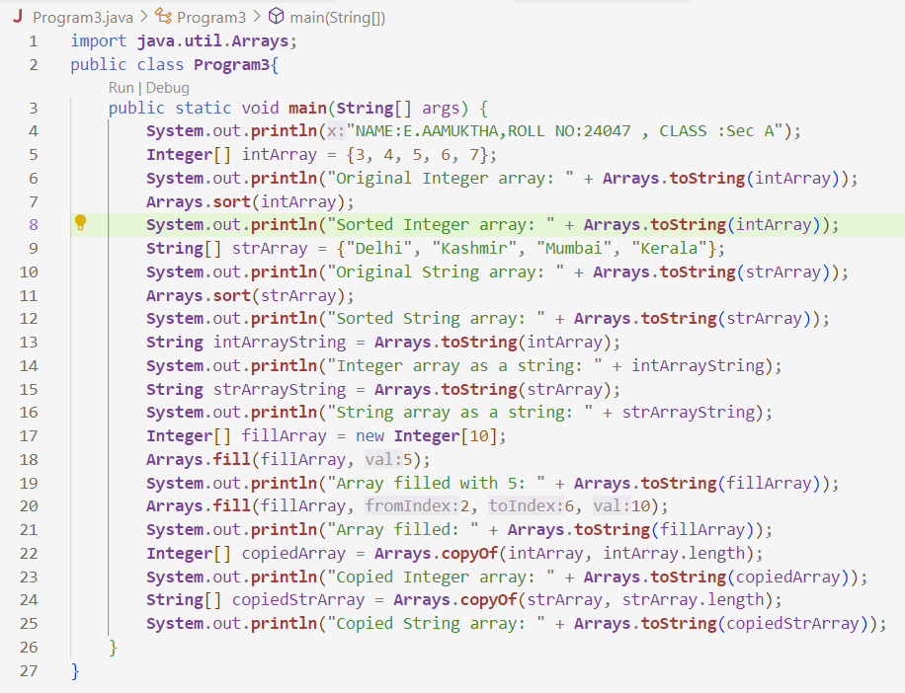

**OUTPUT:**

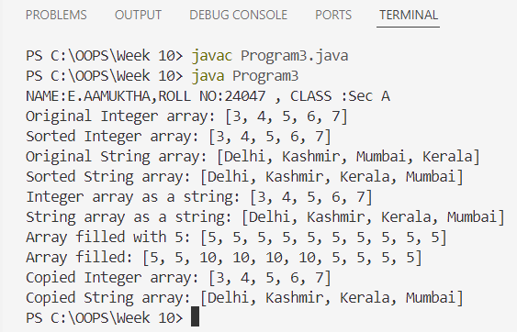

**ERRORS:**

|  |  |
| --- | --- |
| **Code Error** | **Code Rectification** |
| 1. 1. The method toString() in the object is not applicable for the arguments(integer[]) | * + - 1. Declare Array instead of array. |

**IMPORTANT POINTS:**

1. Prints student information at the start.
2. Declares and displays an original Integer array.
3. Sorts the Integer array using Arrays.sort().
4. Declares and displays a String array of fruits.
5. Sorts the String array alphabetically.

**PROGRAM-4:**

**AIM:** Implement a java program using the below Array list method.

* Insert an element at particular index in the array list.
* Modify an element in the array list.
* Access an element from the array list.
* Remove an element from the Array list.
* Clear the elements from the array list.

**CLASS DIAGRAM:**

|  |
| --- |
| **ArrayListExamaple** |
| +flowers: ArrayList<String>  +main(args: String[]): void |

|  |
| --- |
| **ArrayList<T>** |
| +add(E e): Boolean  +add(int index, E element): void  +set(int index, E element): E  +get(int index): E  +remove(int index): E  +clear(): void |

**CODE:**

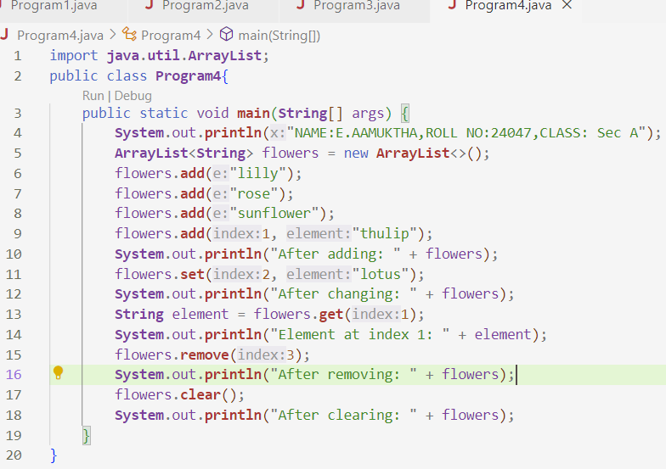

**OUTPUT:**

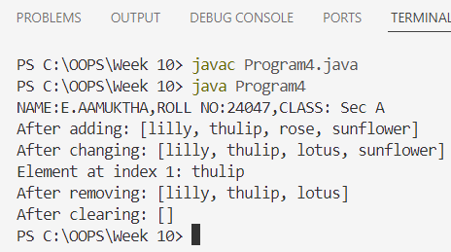

**ERRORS:**

|  |  |
| --- | --- |
| **Code Error** | **Code Rectification** |
| 1. 1. Array list not defined 2. 2. Exception main.java.lang.error; | * + - 1. Define the array list class.   2. Insert() to computer class instance creation expression. |

**IMPORTANT POINTS:**

1. Prints student info at the beginning.
2. Creates an ArrayList of type String named flowers.
3. Adds elements "lilly", "rose", and "sunflower" using add().
4. Inserts "thulip" at index 1 using add(index, element).
5. Replaces element at index 2 with "lotus" using set().